[DELETE DIRECTIONS ONCE READ]
Directions: consider what your story is about and what categories fit the main themes and ideas of your story. Included here are most categories I’ve ever used. You may find that as you’re reading, you need to add a category. Let this be a flexible document! There’s no right or wrong way to do this.
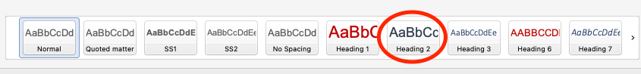
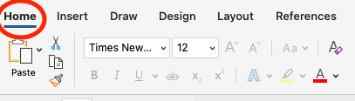
For easy navigation, I set the style for each category title as “Heading 2”. If you add a category, highlight the category title, look at the “styles” section in the home tab, and click on “Heading 2”. That will apply the Heading 2 style to the highlighted text.
To view the category titles, click on the view tab, then click the box next to “navigation pane”. A column will pop up on the left with all category titles. Click on the title you want to jump to!
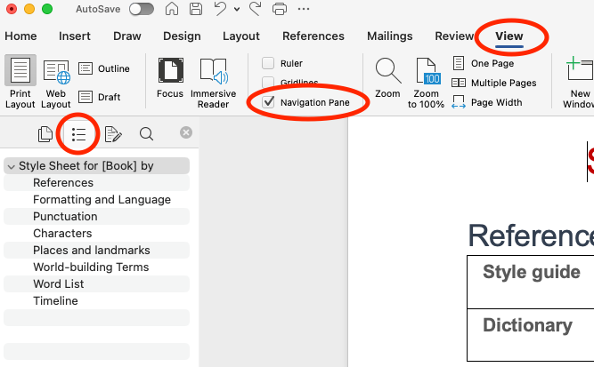
Add categories as you see fit, change the wording in sections, and make this document your own ‘house style sheet’.

Style Sheet for [Book] by [Author]

References
Style guide | The Chicago Manual of Style, 18th edition
Dictionary | Merriam-Webster online dictionary

Formatting and Language
Acronyms | No punctuation (FBI and UK rather than F.B.I. and U.K.)
Chapters | All chapters set on new page and numbers spelled out (Chapter One)
Contractions | Preferred in both narrative and dialogue
Indents | First paragraph of chapter or section not indented; all others set to 0.5
Internal thoughts | Italicised
Numbers | Spell out numbers below 100 and spell out above 100 if rounded in hundreds, thousands, etc.  Spell out numbers in dialogue except for years or unless awkward  Measurements in metric
Profanity | Yes
Section breaks | Three stars (***) with no space in between each, centered with one empty line above and below
Slang/regionalisms | Southern (y’all, bless her heart)
Words as words | Use quotation marks for words as words: He said “love” like he didn’t mean it.  If there are several words within a short period or the word is used within quotation marks, use italics: “M-W defines justice as…”

Punctuation
Commas | Oxford/serial comma  Commas used only when needed—use a light hand  Comma before terminal too, either, though (except short sentences)  Comma precedes then when short for and then
Colon | Capitalise first word if followed by a complete sentence or question
Ellipses | Used for trailing speech and thoughts. Three dots (not four) after completed sentence.  Ellipsis character (…), not spaced periods  Closed with preceding word
Em dashes | Do not retain question mark in question that’s cut off (“How did you—” instead of “How did you—?”)  Used for sudden breaks in thought, speech, or sentence structure  Unspaced on either side
Hyphens | Colour compounds: hyphen before noun  Half compounds: hyphen if adjectives, but not noun or verb forms  Like compounds: hyphen if not found in M-W  Well compounds: hyphen if before noun or are hyphenated in M-W
Quotation marks | Doubles with nested singles
Semicolons | Used sparingly

Characters
A list of all characters in the story, which can be organised by appearance, alphabetically, or in significant groups (by family, role, etc.). Typically, this list will include each character’s full name, pronouns, nicknames, titles, physical descriptions, roles and relationships, personality traits, and anything that’s important to track.
If this style sheet covers a series of books, you may want to put the book in which they appear in brackets.

Places and landmarks
All geographical places and landmarks mentioned in the story

World-building Terms
Terms that are unique to the setting, especially common in science fiction and fantasy novels. If the story takes place in the real world, this may not be needed. This section is broken down into various subheadings. Add or remove as needed.

Unique Terms and Phrases
Made up words/insults/curses or concepts. For new words add what the ‘real’ word means in parentheses e.g. Dodgast (gosh darn). (See Other Languages for additional information)

Cultures
A list of the main cultures and details about them, like laws, structure, jobs and industries, where they live, etc.

Magic System/Technology
The rules, what it can do, limitations, learning, etc.

Magic Objects/Special Tech
List of properties, descriptions, limitations, etc.

Items of Interest
If an object is mentioned and will be relevant in the story, add it here. This may overlap with magic objects or special tech, but add it to whichever section you feel most relevant.

Nature
List of flora and fauna with physical descriptions and anything else relevant about them.

Other Languages
If there are just a few words here and there (real or made up), list them in Unique Terms and Phrases. If there is a whole language system, or use of other real languages (Spanish, French, etc), list them here.

Word List
In alphabetical order, list unique or variant spellings, treatment of compound terms (hyphenated vs. open vs. closed), and special capitalisation.
For example:
a.m and p.m (small caps)
blow-dry (v)
Bluetooth
break-in (n)
café
double-check (v)
driver-side door
facade
forestlike
ooh [interjection]
T-shirt
voicemail [var.]
yep

Timeline
Keep track of timeline details here, including the year, month, day of the week, and time of day that significant events take place. If the events of the story are linear or the timeline isn’t too complex, you might prefer using chapter summaries instead.

